Systems approach and cybernetics; engaging in the future of mankind.

The significance of systems and cybernetics in the future of societies.

Invitation for active participation
Increasingly, people and institutions are recognizing the systemic nature of our world and the relevance of systemic thinking as a foundation to deal with the complexity of technological, social, environmental and economic issues.

With the support of the Russian Academy of Sciences (RAS), WOSC is organising its 18th Congress- WOSC 2020, from the 16th to the 18th of September 2020.

In this Congress, we are addressing young and senior creative researchers, who are willing to share and develop systemic perspectives on how to understand and manage the future of humanity.
The Congress mission is related to the notions of requisite variety and transdisciplinary research by sharing active support among researchers from all disciplines in a supportive working environment.

For this purpose, WOSC 2020 is focusing on the following four themes:

1.Philosophical and methodological foundations for the development of the systems approach and cybernetics

2.The cybernetics of society, ecology and governance

3.Technology and humanity: co-developing a hybrid reality

4.Transdisciplinarity of systems sciences and cybernetics: developing areas of knowledge
- Learning, Teaching and Education
- Health, Healthcare and Medicine
- Business and Economy
- Hospitality and Tourism
AUTHOR GUIDELINES
In WOSC 2020, a 2 step publishing process will be used to enable you to share and discuss your research with peers and help you to clarify your perspectives. We shall test the thesis that a supportive heterogenic research environment results in true systems thinking results. More than that; we will encourage you to support your peers and to develop capacities of forming international teams, capable of attracting research funding.
Step 1. Abstracts
Researchers, managers, policy-makers, professionals and students across the globe are invited to submit abstract proposals, of about 250 to 500 words (see abstract/paper template), addressing the Congress topics by the 31st January 2020. You may expect to receive feedback by your co-coordinators in up to 14 days of your submission, but not later than on the 31st of March 2020. Accepted abstracts will be published in a Congress book of abstracts.
Step 2. Full conference papers
Registered authors with an accepted abstract can submit a full conference paper by the 31st of July 2020. Full conference papers should not exceed 5000 words (see abstract/paper template). In step 2 your peers will suggest you how to deal with the research issues before being published in the Congress proceedings.
At the congress, authors will present their contributions, enhanced by reviewers comments, to receive support for further research.
Best paper author and best review will be awarded at the Congress.
Basic rules
- Authors should make sure that the language of their papers meets the required standards.
- Authors can submit one paper per registration. For the second paper submission, discounted registration rates apply.
- The authors are responsible for the originality and the proper referencing standards in their papers. Papers with any kind of plagiarism will be systematically excluded from publication.

Submission
For the submission please use the abstract/paper template containing detailed author guidelines.

You may start the submission process by creating a WOSC 2020 account
PUBLICATIONS
WOSC congresses are well recognised by publishers. After publishing your contributions in WOSC2020 Congress book of abstracts and WOSC2020 Congress proceedings, authors of best contributions will be invited to publish their fully developed papers in special issues of high ranking scientific journals such as:
Kybernetes,
Systems research and behavioral science,
Cybernetics and systems,
Sustainability,
International Journal of Systems and Society,
Organizacija,
Control Sciences,
Russian Journal of Philosophical Sciences,
Advances in Systems Science and Applications.
These journals are indexed in scientific indexes, such as Journal Citation Reports, Scopus, RSCI and others. Processes for journal submissions are elaborated by the individual journal editorial policy. We expect special issues of the related journals with the selected papers to be published during 2021.

REGISTRATION:
Participant | early bird | regular
Regular | 300,00 € | 400,00 €
discounted/ accompany persons/ additional paper | 100,00 € | 150,00 €

To receive payment details and an invoice, please send a message to info@WOSC2020.org
In case, you would like to apply for a discount registration, please explain situation and submit relevant evidence in the message to the organisational team.

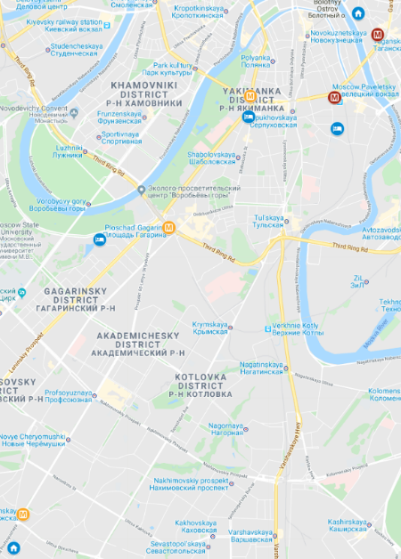
VENUES:
V. A. Trapeznikov Institute of Control Sciences of Russian Academy of Sciences
Address: Profsoyuznaya Street, 65, Moscow, Russia, 117342
Metro: 3 min to Metro line 6 Kaluzhskaya

Institute of Philosophy, Russian Academy of Sciences
Address: Goncharnaya Street, 12/1, Moscow, Russia, 109240
Metro: 5 min to Metro line 5 Taganskaya

IMPORTANT DATES
31 January 2020: Abstract Submission deadline
31 March 2020: Notification of acceptance
30 June 2020: Submission of conference full papers deadline and
Early bird registration deadline
15 July 2020: Review deadline
31 August 2020: Submission of revised conference full papers and Registration deadline for accepted authors
15 Sept 2020: Registration deadline for non-presenters
16-18 September: WOSC 2020 Congress

You may find additional information at https://www.WOSC2020.org/

Get in contact at info@WOSC2020.org

your WOSC 2020 team

